1.Scenario: A company wants to calculate the monthly salary of its employees, including allowances and deductions.
Requirements:
- Create a class EmployeeSalary. 2. Create a method calculateSalary() that accepts basic salary and allowance and returns the gross salary. 3. Create a method calculateNetSalary() that accepts gross salary and deductions and returns the net salary. 4. Create a method displayDetails() to display the employee name, gross salary, and net salary. 5. Call all methods from main() without using a constructor. Sample input: Basic salary = ₹25,000, Allowance = ₹5,000, Deductions = ₹2,000.
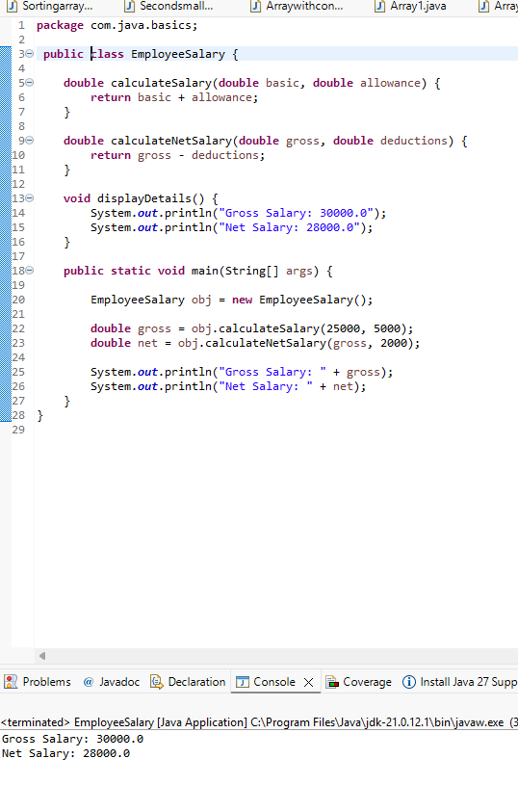
2.Scenario: A college wants to calculate students' results based on five subject marks. Requirements:
1. Create a class StudentResult. 2. Create a method calculateTotal() that accepts five subject marks and returns the total. 3. Create a method calculateAverage() that accepts the total and returns the average. 4. Create a method calculateGrade() that accepts the average and returns a grade: ○ 90 and above: A ○ 75–89: B ○ 50–74: C ○ Below 50: Fail 5. Create a method to display the total, average, and grade. Sample input: 85, 78, 92, 88, 77. Expected output: Total: 420 Average: 84.0 Grade: B
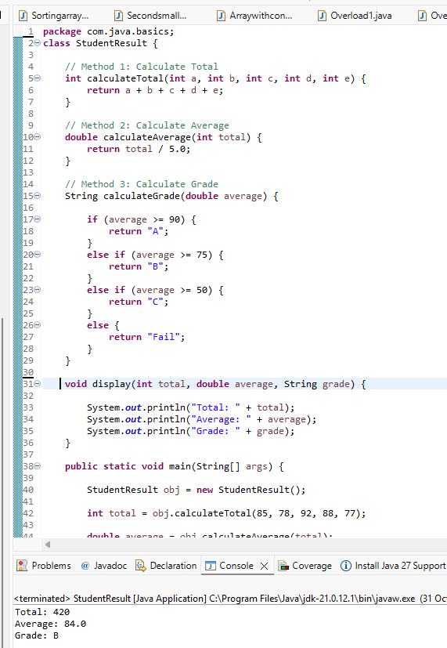
3.Scenario: An online shopping application calculates the final bill based on the purchase amount and membership type.
Requirements: 1. Create a class ShoppingCart. 2. Create a method calculateTotal() that accepts the prices of three products and returns the total. 3. Create a method calculateDiscount() that accepts the total and membership type. Apply: ○ Gold: 20% discount ○ Silver: 10% discount ○ Regular: 5% discount 4. Create a method calculateFinalAmount() that returns the amount after discount. 5. Create a method to display the total, discount, and final amount. Sample input: ₹2,000, ₹1,500, ₹500; membership = Gold. Expected output: Total Amount: 4000.0 Discount: 800.0 Final Amount: 3200.0
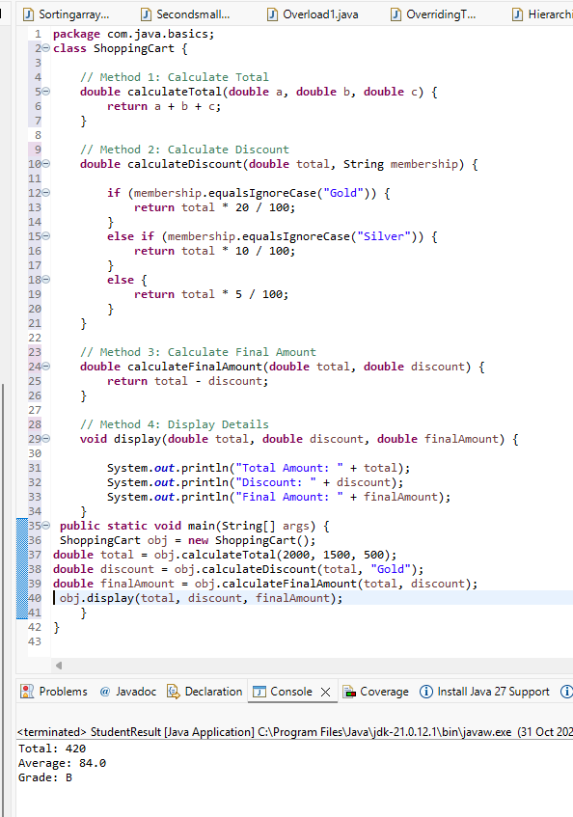

4.Scenario: An electricity board calculates a household bill based on units consumed. Requirements:
1. Create a class ElectricityBill. 2. Create a method calculateBill() that accepts the number of units consumed and returns the bill amount using these slabs: ○ First 100 units: ₹2 per unit ○ Next 100 units: ₹3 per unit ○ Above 200 units: ₹5 per unit 3. Apply the rates progressively. For example, 250 units means 100 units at ₹2, 100 units at ₹3, and 50 units at ₹5. 4. Create a method addFixedCharge() that accepts the bill amount and adds a fixed charge of ₹50. 5. Create a method to display the final bill. Sample input: 250 units.
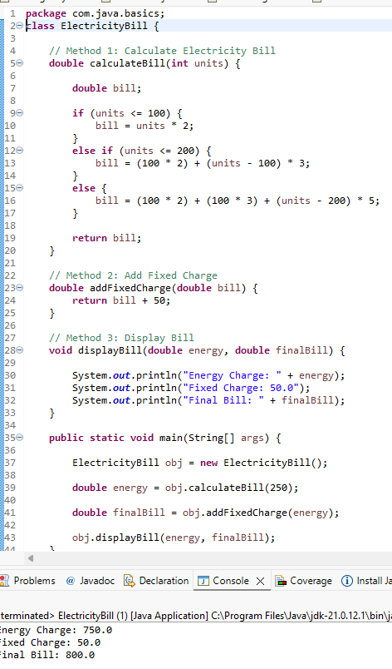
5.Scenario: A bank needs a simple application to perform deposits, withdrawals, and balance checks. Requirements: 1. Create a class BankingOperations. 2. Create a method deposit() that accepts the current balance and deposit amount and returns the updated balance. 3. Create a method withdraw() that accepts the current balance and withdrawal amount. If sufficient funds are unavailable, display an appropriate message. 4. Create a method checkBalance() that accepts the current balance and displays it. 5. Create a method displayTransactionSummary() that displays the deposit amount, withdrawal amount, and final balance. 6. Call all methods from main() without using constructors. Sample input: ● Initial balance: ₹5,000 ● Deposit: ₹2,000 ● Withdrawal: ₹1,500


